Preliminary analysis - Martha dataset

Table of Contents

1 Suicidal ideation 1

1.1 Network graph 1

1.2 Pairwise meta-analysis 2

1.3 Mantel-Haenszel network meta-analysis 3

1.4 Inverse variance network meta-analysis 4

2 Nausea 5

2.1 Network graph 5

2.2 Pairwise meta-analysis 5

2.3 Random effects network meta-analysis 6

3 Agitation 7

3.1 Network graph 7

3.2 Pairwise meta-analysis 8

3.3 Random effects network meta-analysis 9

4 Tremor 10

4.1 Network graph 10

4.2 Pairwise meta-analysis 11

4.3 Random effects network meta-analysis 12

# Suicidal ideation

## Network graph

We included a total of 44 studies in the analysis of this outcome. We had a total of 101 events in placebo and 159 events in drugs.

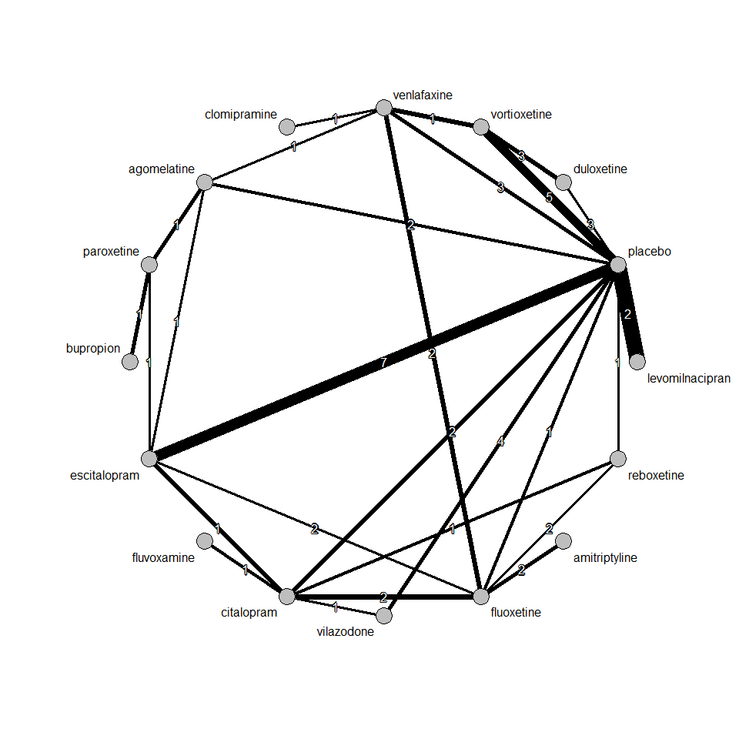

## Pairwise meta-analysis

After grouping all drugs under one node, we performed a pairwise meta-analysis between drugs vs placebo. We used Mantel-Haenszel method to synthesize odds ratios. We found a very small effect size with large uncertainty, i.e. an OR 1.07 [0.82, 1.38], favouring placebo. The random effects model gave almost identical results.

Number of studies combined: k = 40  
  
 OR 95%-CI z p-value  
Fixed effect model 1.07 [0.82; 1.38] 0.49 0.62  
Random effects model 1.02 [0.78; 1.35] 0.17 0.86  
  
Quantifying heterogeneity:  
tau^2 = 0; H = 1.00 [1.00; 1.00]; I^2 = 0.0% [0.0%; 0.0%]  
  
Test of heterogeneity:  
 Q d.f. p-value  
 23.06 39 0.9801  
  
Details on meta-analytical method:  
- Mantel-Haenszel method  
- DerSimonian-Laird estimator for tau^2  
- Continuity correction of 0.5 in studies with zero cell frequencies

We present contour-enhanced funnel plot. We don’t see asymmetry in the funnel plot. Thus, we can conclude that there is no publication bias in this study.

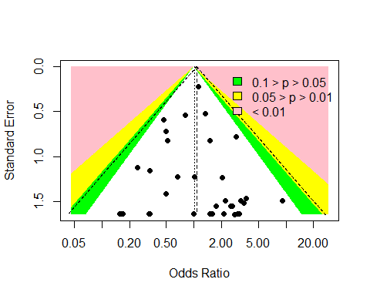

## Mantel-Haenszel network meta-analysis

We performed a Mantel-Haenszel NMA. Results are summarized in the forest plot below. Odds ratio smaller than 1 indicate that a drug reduced suicidal ideation as compared to placebo. All estimates come with large uncertainty; thus, no firm conclusion can be drawn for any of the drugs.

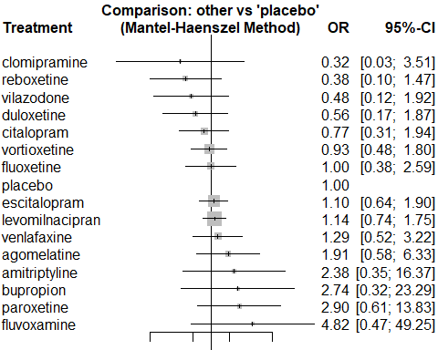

## Inverse variance network meta-analysis

The estimates found by using inverse variance method for both fixed and random effects model closely match the result we found in Mantel-Haenszel NMA. There are more treatments included in this NMA since a continuity correction (adding 0.5 to no event arms) has been used. Fixed and random effects NMA gave identical results, because heterogeneity was estimated to be zero.

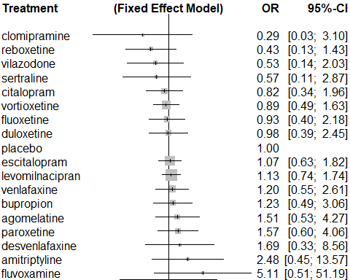

# Nausea

## Network graph

We included a total of 181 studies in the analysis of this outcome. We had a total of 1997 events in placebo and 8040 events in drugs.

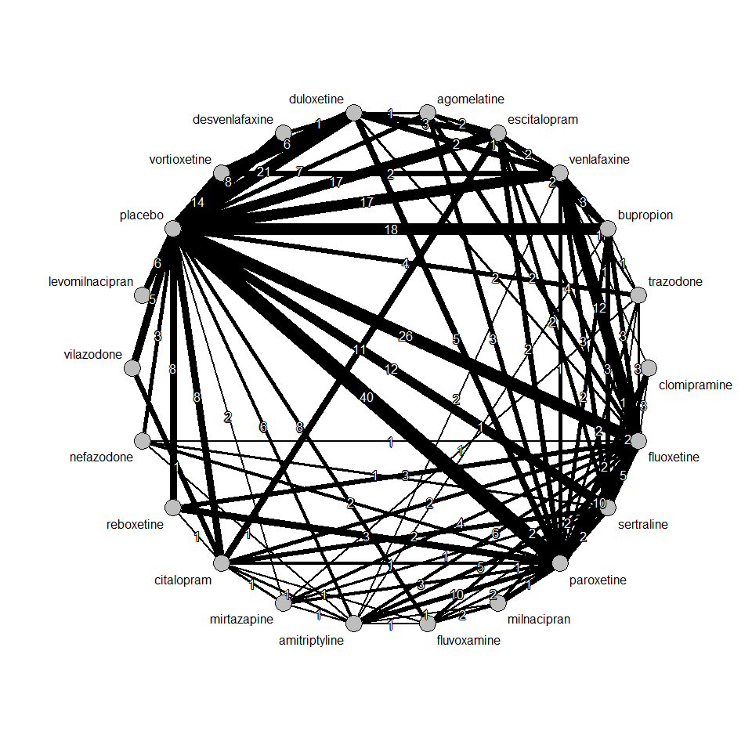

## Pairwise meta-analysis

After grouping all drugs under one node, we performed a pairwise meta-analysis between drugs vs placebo. We used Mantel-Haenszel method to synthesize odds ratios. We found a very **large** effect size with small uncertainty, i.e. an OR 2.59 [2.46, 2.74], favouring placebo.

Number of studies combined: k = 181  
  
 OR 95%-CI z p-value  
Fixed effect model 2.59 [2.46; 2.74] 34.61 < 0.01  
Random effects model 2.53 [2.32; 2.75] 21.35 < 0.01  
  
Quantifying heterogeneity:  
tau^2 = 0.1625; H = 1.46 [1.34; 1.59]; I^2 = 53.2% [44.6%; 60.5%]  
  
Test of heterogeneity:  
 Q d.f. p-value  
 384.88 180 < 0.0001  
  
Details on meta-analytical method:  
- Mantel-Haenszel method  
- DerSimonian-Laird estimator for tau^2  
- Continuity correction of 0.5 in studies with zero cell frequencies

We present contour-enhanced funnel plot below. We don’t see asymmetry in the funnel plot. Thus, we can conclude that there is no publication bias in this study.

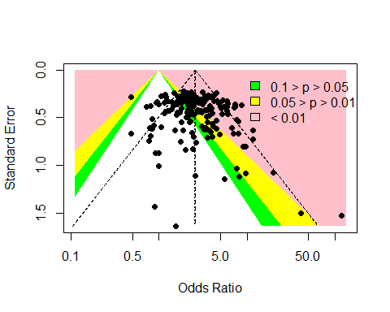

## Random effects network meta-analysis

We performed a random effects NMA. Results are summarized in the forest plot below. Odds ratio smaller than 1 indicate that a drug reduced nausea as compared to placebo. Odds ratios are much greater than 1 with small uncertainty; thus, we can infer that drug may be developing nausea for some patients.

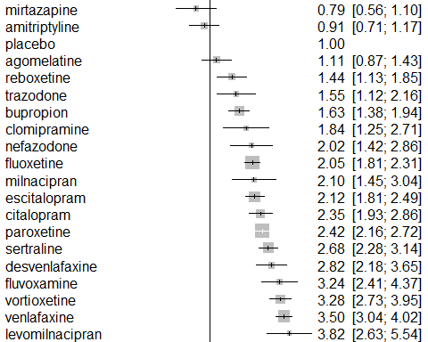

# Agitation

## Network graph

We included a total of 42 studies in the analysis of this outcome. We had a total of 262 events in placebo and 501 events in drugs.

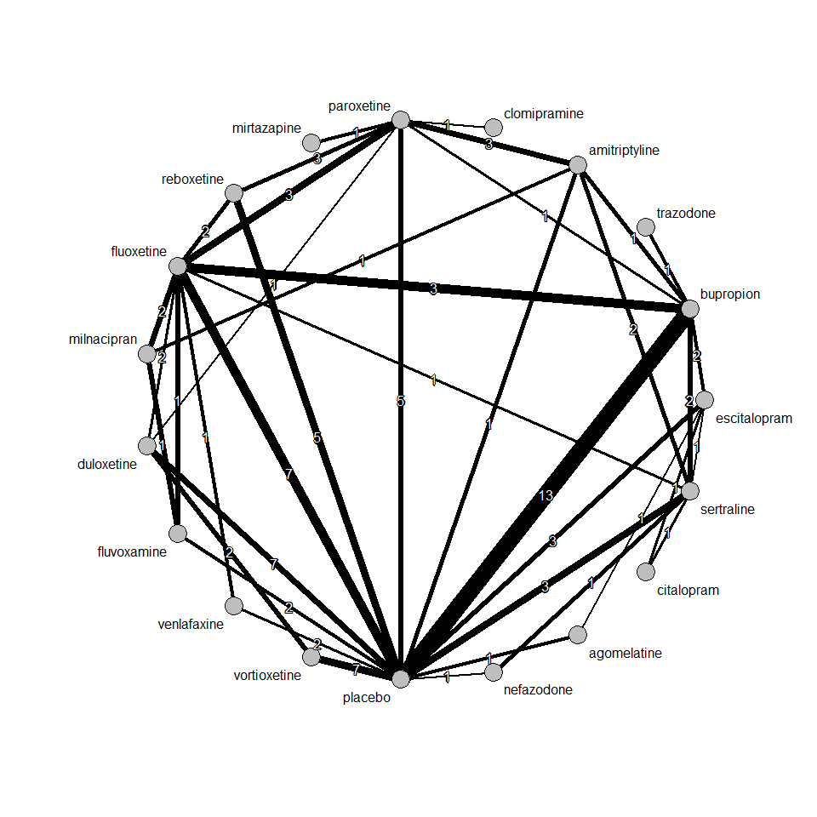

## Pairwise meta-analysis

After grouping all drugs under one node, we performed a pairwise meta-analysis between drugs vs placebo. We used Mantel-Haenszel method to synthesize odds ratios. We found a small effect size with moderate uncertainty, i.e. an OR 1.17 [0.99, 1.40], favouring placebo.

Number of studies combined: k = 42  
  
 OR 95%-CI z p-value  
Fixed effect model 1.17 [0.99; 1.40] 1.81 0.07  
Random effects model 1.13 [0.90; 1.41] 1.04 0.30  
  
Quantifying heterogeneity:  
tau^2 = 0.1150; H = 1.14 [1.00; 1.39]; I^2 = 23.4% [0.0%; 48.1%]  
  
Test of heterogeneity:  
 Q d.f. p-value  
 53.56 41 0.0904  
  
Details on meta-analytical method:  
- Mantel-Haenszel method  
- DerSimonian-Laird estimator for tau^2  
- Continuity correction of 0.5 in studies with zero cell frequencies

We present contour-enhanced funnel plot below. We don’t see asymmetry in the funnel plot. Thus, we can conclude that there is no publication bias in this study.

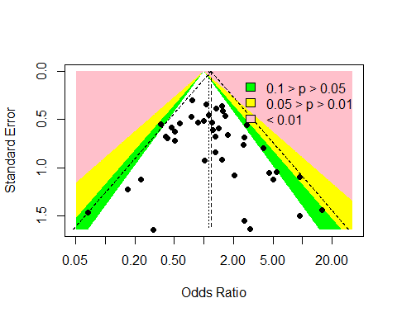

## Random effects network meta-analysis

We performed a random effects NMA. Results are summarized in the forest plot below. Odds ratio smaller than 1 indicate that a drug reduced agitation as compared to placebo. All estimates come with large uncertainty; thus, no firm conclusion can be drawn for any of the drugs.

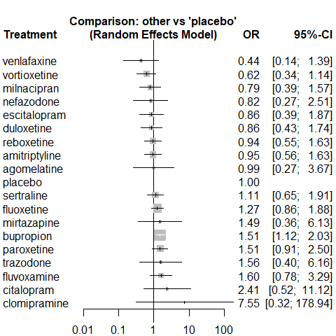

# Tremor

## Network graph

We included a total of 74 studies in the analysis of this outcome. We had a total of 128 events in placebo and 950 events in drugs.

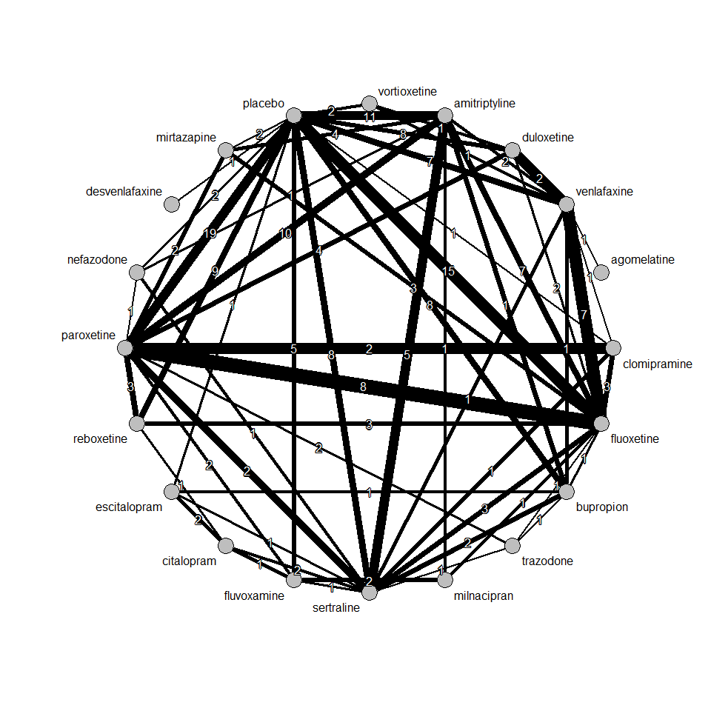

## Pairwise meta-analysis

After grouping all drugs under one node, we performed a pairwise meta-analysis between drugs vs placebo. We used Mantel-Haenszel method to synthesize odds ratios. We found a large effect size with small uncertainty, i.e. an OR 4.22 [3.50, 5.10], favouring placebo.

Number of studies combined: k = 73  
  
 OR 95%-CI z p-value  
Fixed effect model 4.22 [3.50; 5.10] 14.93 < 0.01  
Random effects model 3.56 [2.93; 4.34] 12.69 < 0.01  
  
Quantifying heterogeneity:  
tau^2 = 0; H = 1.00 [1.00; 1.10]; I^2 = 0.0% [0.0%; 17.8%]  
  
Test of heterogeneity:  
 Q d.f. p-value  
 63.04 72 0.7655  
  
Details on meta-analytical method:  
- Mantel-Haenszel method  
- DerSimonian-Laird estimator for tau^2  
- Continuity correction of 0.5 in studies with zero cell frequencies

We present contour-enhanced funnel plot below. There might be a publication bias since studies with low precision are not spread evenly on both sides of the average.

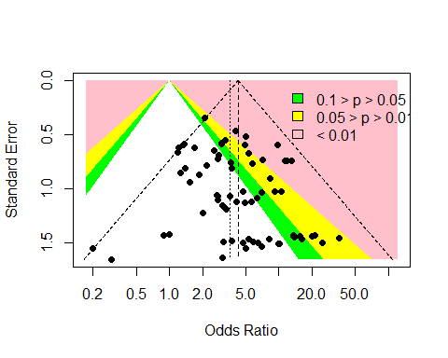

## Random effects network meta-analysis

We performed a random effects NMA. Results are summarized in the forest plot below. Odds ratio smaller than 1 indicate that a drug reduced tremor as compared to placebo. Odds ratio are large with small uncertainty; thus, we can infer that drug may be developing tremor for some patients.

